# TITLE OF CONTRIBUTION

Name and Surname[1]*

The present document presents the technical writing standard for and is at the same time a writing example for contributions for the *Ephemeris Dacoromana* annual journal.

The format of the **TITLE** of the contribution is: Times New Roman, 12, Bold, ALL CAPS, single spaced, centred, easily selected with [ED] Heading 1.

The *name of the author* has the following format: Times New Roman, 11, *Italic*, easily selected with [ED] Date, Author.

The text of the article is written in Times New Roman, 11, 0.5" Indentation, Justified, single line spacing, no space between paragraphs, no hyphenation. The text contains Tabs. The style is easily selected with [ED] Normal. Any other type of formatting will be eliminated.

## Chapter 1

If the text of the article contains chapters or sections, the titles of such chapters or sections will be written in Times New Roman, 12, Bold, centred, small caps, easily selected with [ED] Heading 2.

## Quotes and notes

Quoting fragments of texts taken from expert sources or bibliography to be written in Cursive, both in the body of the text and in the notes, exclusively marked with Angle quotes «…».

Moreover, longer fragments quoted in the text will be written in Times New Roman, 10, with a spacing of 8 points before and after, and with an Indent for all lines of 0.5" both on the left and on the right.

Words or phrases that were omitted from the quoted fragments will be emphasised by using ellipsis in between straight brackets […].

Regardless of typology and consistency, bibliographic references should be inserted in the footnotes, at the bottom of the page, from the beginning to end, rigorously and chronologically, from the most former year of publication to the most recent one; it is only in the case of titles publishes in the same years that the references should be written in alphabetical order based on the author’s surname.

Footnotes: insert by accessing the Reference page on the Menu bar, Insert Footnote (Ctrl+Alt+F). Footnotes are written in Times New Roman, 10, single spaced, easily inserted with [ΕD] Footnote.

Quotation of books: order of bibliographic references - author, title, publishing house, city, year, page, as in the example below,[2] and beginning with the second quotation the initial of the name is indicated, the surname, the first word (or the first two words) of the title indicated by cit., and the page.[3] Op. cit. should not be inserted.

Consecutive quotations taken from the same book: *Ibidem* in Italics should be used and the page should be indicated if different.[4]

Consecutive quotations from various books by the same author: *Idem*, title, publishing house, city, year.[5]

Examples for: quotations of articles published in journals[6] or in collective volumes[7] and from the second quotation.[8]

Regarding contributions in English: use ed. when talking about one editor and eds. when there are more editors.

The second quotation of the same article or volume: insertion in the footnote of author’s abbreviated name, author’s full surname in Small capitals [ED] Heading 2, and the abbreviations of the title: R. Mastronardi, *La marineria* cit., p. 18.

Quoting archives and manuscripts: full name of the archive or the library in the first insertion in the footnote;[9] for the second insertion – the abbreviated name of the archive[10]. Name of the fund to be written in *Italics*.

Internet sources[11].

According to the Italian practice, before the punctuation the number of the footnote should be inserted. However, in the case of texts written in English, there is a preference for the Anglo-Saxon practice of inserting the number of the footnote after the punctuation mark.

**NB:**

There is no need for a Bibliography at the end of one’s own article, as the rigorous bibliographic references in the footnotes should be fully relevant for the quality and the importance of the article. Nonetheless, if the author prefers to insert a list of bibliography at the end of the article, it should look as below.

The list of abbreviations in the text is also optional.

For contributions containing images, a list of titles of the images should be inserted, indicating the number, Tab, title. Further, the images will be inserted one after the other, no more than 2 per page, with the indication Figure 1, Figure 2, etc., without adding a title. To insert, we right click on the image, Insert caption. The format of the indication should be centred, Bold, 10 pt, Times New Roman.

The order of the optional sections should be: Abbreviations, List of Figures, Images, Bibliography.

When sending in a contribution, the images should also be sent separately from the article.

**NB:**

The names of authors will be written in Small Caps (select, Ctrl+D, Small Caps).

## ABBREVIATIONS (OPTIONAL)

*AA Archäologischer Anzeiger*

*ASMOSIA Association for the Study of Marble and Other Stones in*

*Antiquity*

*JRS Journal of Roman Studies*

*PBSR*  *Papers of the British School at Rome*

## LIST OF FIGURES

1. *How to insert a photograph*
2. *Second example*

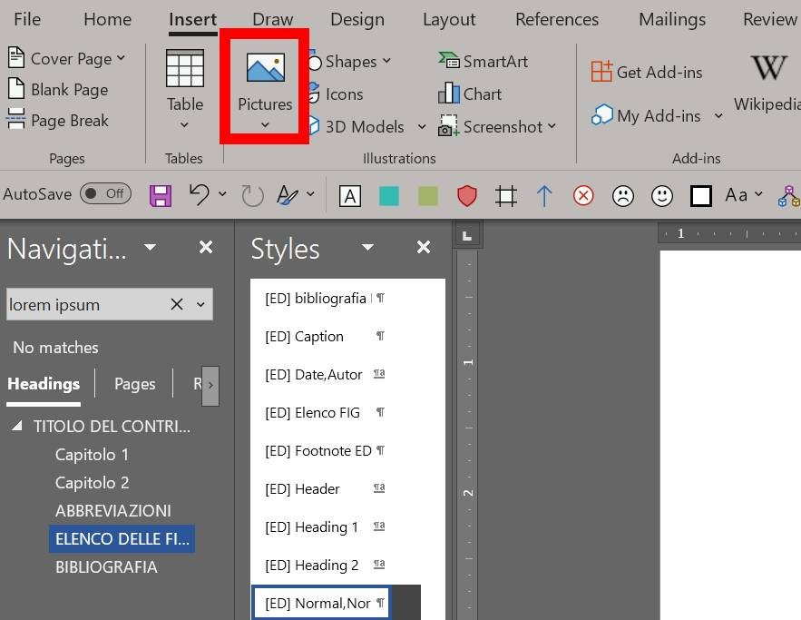

Fig. 1.



Fig. 2. Etc.

## BIBLIOGRAPHY

Asgari 1988

Asgari N., “The stages of workmanship of the Corinthian capital in Proconnesus and its export formˮ, in Hertz N., Waelkens M. (a cura di), *Asmosia I, Classical Marble: Geochemistry, Technology, Trade,* *Proceedings of the Nato Advanced Research Workshop on Marble in Ancient Greece and Rome: Geology, Quarries, Commerce, Artifacts (Lucca, 9 – 13 maggio 1988)*, Dordrecht-London-Boston, 115-137.

Bruno – Bianchi 2015b

Bruno M., Bianchi F., *Marmi di Leptis Magna. repertorio delle pietre bianche e policrome della città*, Roma.

Chiesa 1949

Chiesa C., “Sui materiali da costruzione di provenienza locale usati dagli antichi in Tripolitaniaˮ, *Reports and Monographs of the Department of Antiquities in Tripolitania*, 2, 25-28.

Cordovana 2007

Cordovana D. O., *Segni e immagini del potere tra antioc e tardo antico. I Severi e la Provincia* Africa Proconsularis, Catania.

Pensabene P., “Il fenomeno del marmo nel mondo romanoˮ, in De Nuccio M., Ungaro L. (a cura di), *I marmi colorati della Roma imperiale*, Venezia, 3-67.

1. * Affiliation and e-mail address.
2. Giacomo Cosmi, Genova nel XVI secolo, Laterza, Alessandria 1981, p. 71-75.
3. G. Cosmi, *Genova* cit., p. 83.
4. *Ibidem*, p. 26.
5. *Idem*, *Sulla struttura originaria delle spade sarde*, Palombi, Roma, 1950, pp. 25-26.
6. Rinaldo Mastronardi, *La marineria amalfitana*, in «Rivista del Mediterraneo», XII, no. 32, 1968, p. 15-23.
7. Flavio Barindi, *Echi della battaglia di Lepanto nella letteratura spagnola del Seicento*, in *Storia e letteratura* *nell’Europa* *della* *prima* *Età* *moderna*, edited by Emilio Benitez, Marco Gramini, Franco Rossi, Laterza, Siena 1971, p. 234-236.
8. R. Mastronardi, *La marineria* cit., p. 21; F. Barindi, *Echi della battaglia* cit., p. 241.
9. Trieste State Archive (hereinafter TSA), *Capitaneria di Porto*, b. [busta] 42, c. [carta] 64.
10. AST, *Capitaneria di Porto*, b. 81, c. 23.
11. „Jerry N. Hess oral interview of Walter H Judd”, 13 April 1970, <http://www.trumanlibrary.org/oralhist/judd.htm>, accessed 16.04.2004.